1. 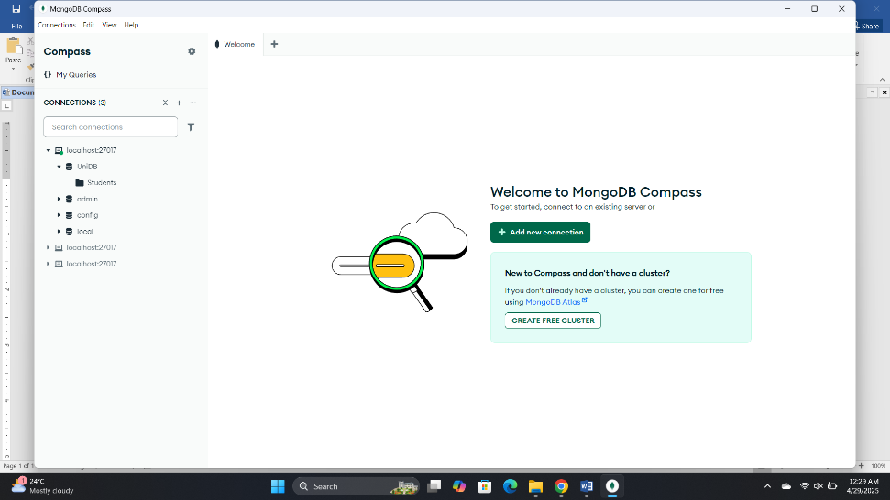Open MongoDB Compass
2. Create New Connection
3. Save & Connect
4. Creating Database:

* Go to localhost
* Click (+)
* Add database name
* 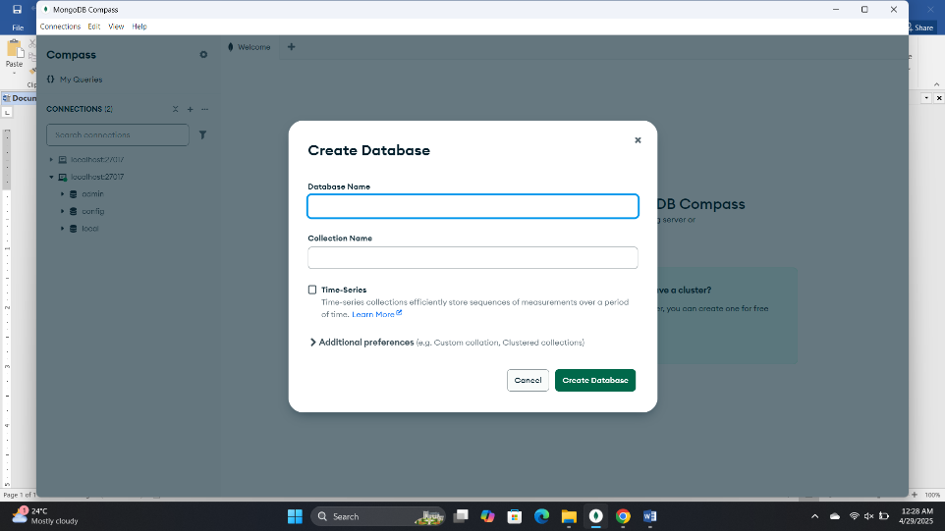Add Collection name

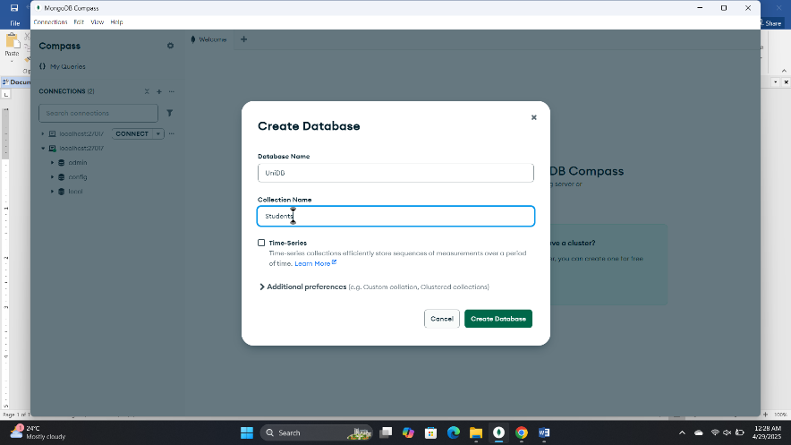

* 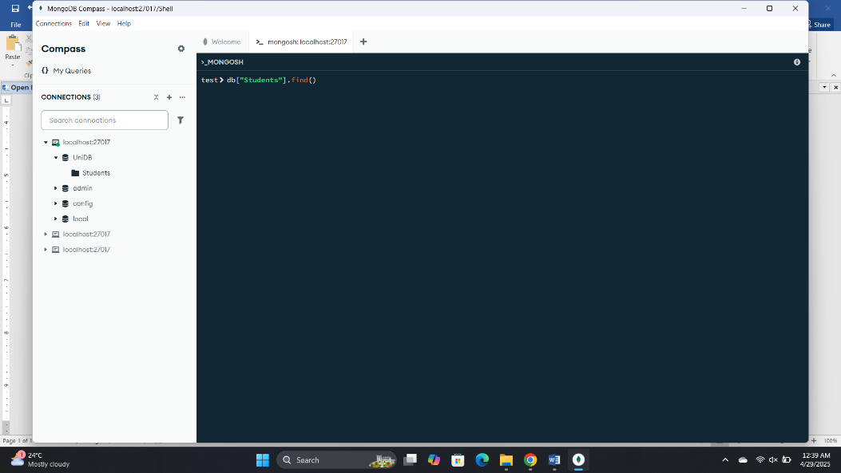Open Shell
* Type use ' uniDB' for change the database

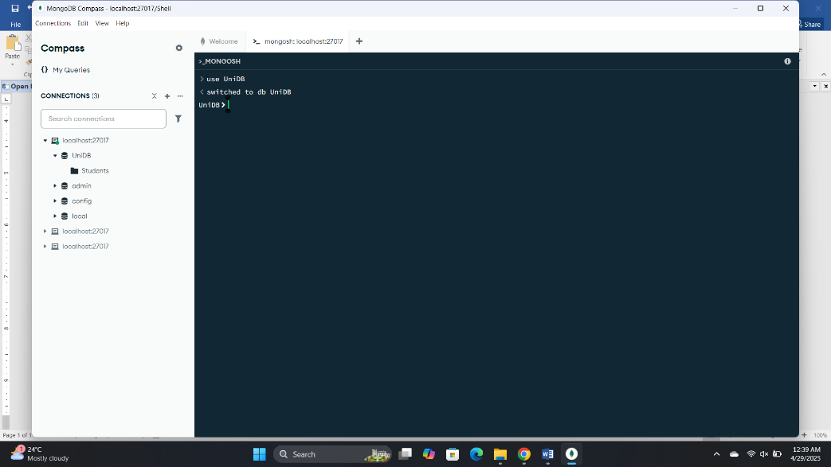

* 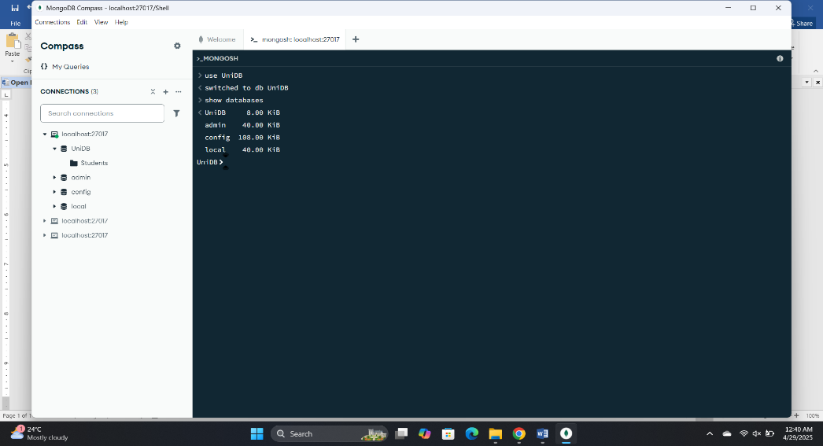Type show databases to display all the databases existing
* Type show collections to display all the collections

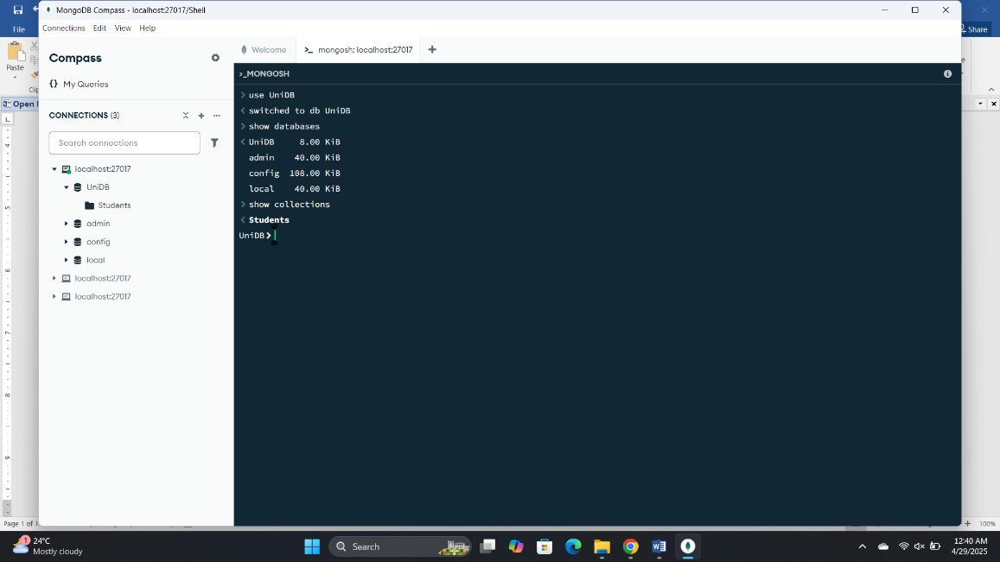

* 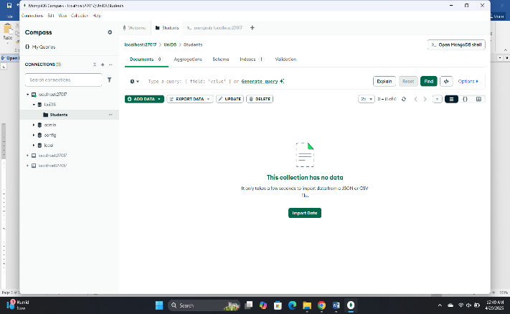Click ' students'
* Click ' Add data '
* Click ' Insert Document'

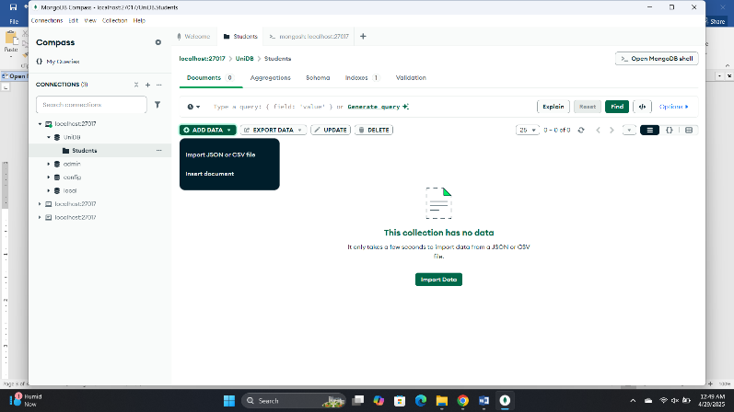

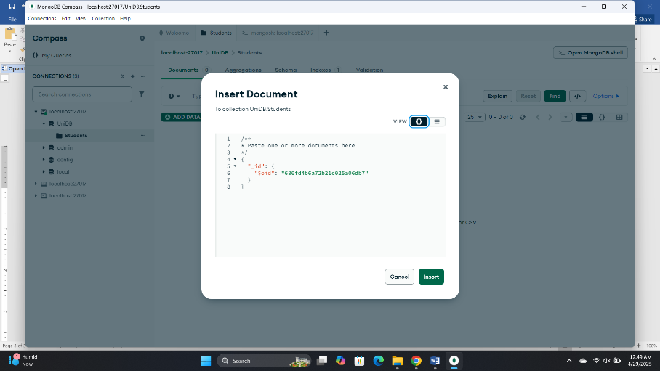

//Inserting Data Using Shell (Only One Data)

* We use insertOne

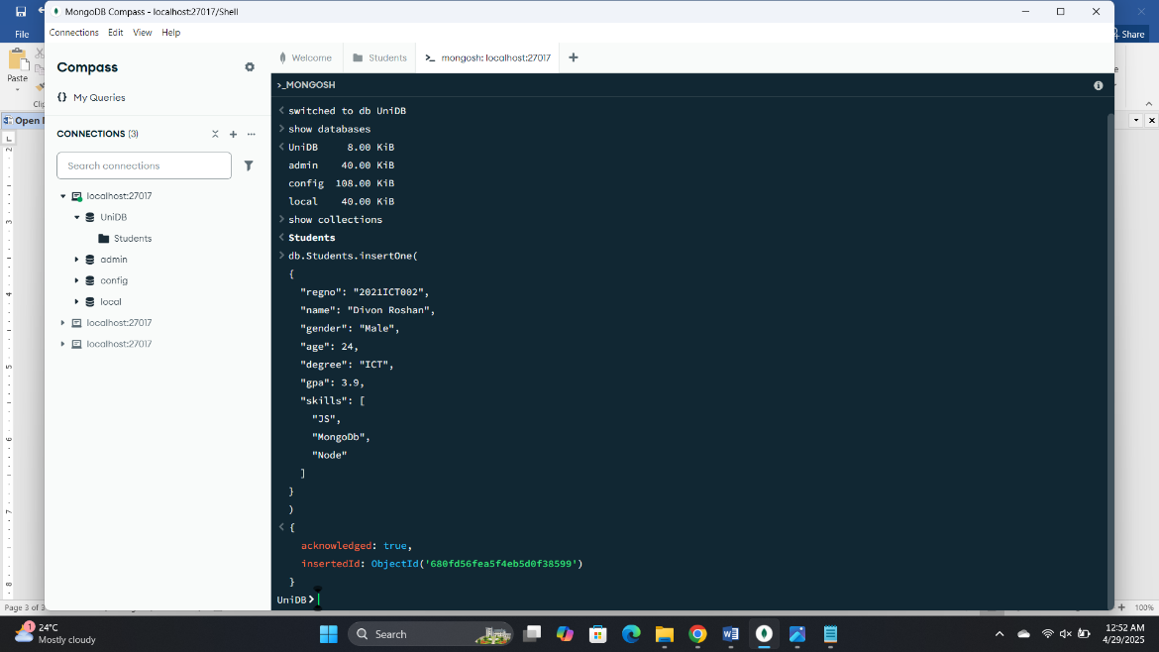

(Inserting Many Data Using Shell)

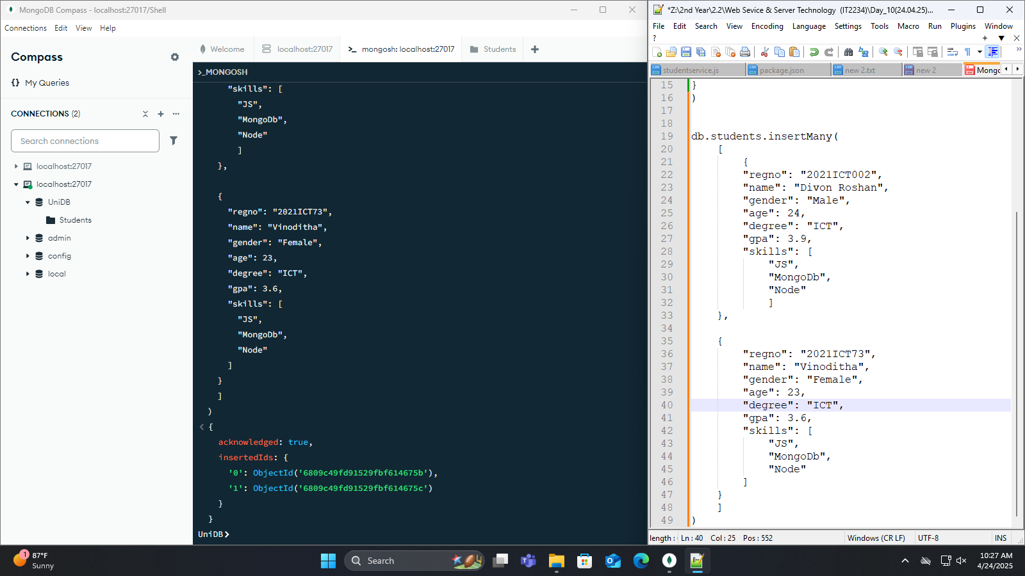

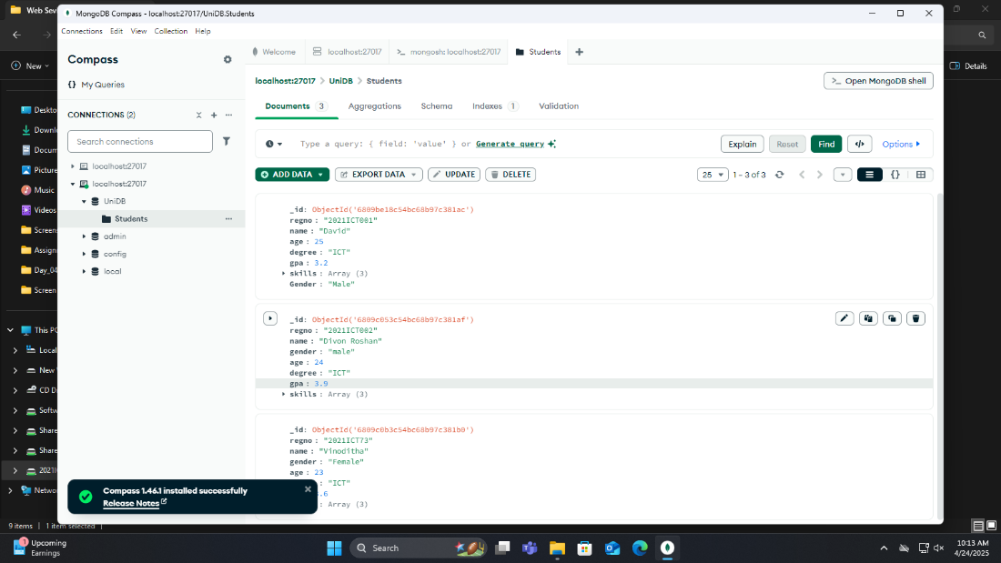Inserting data Using GUI

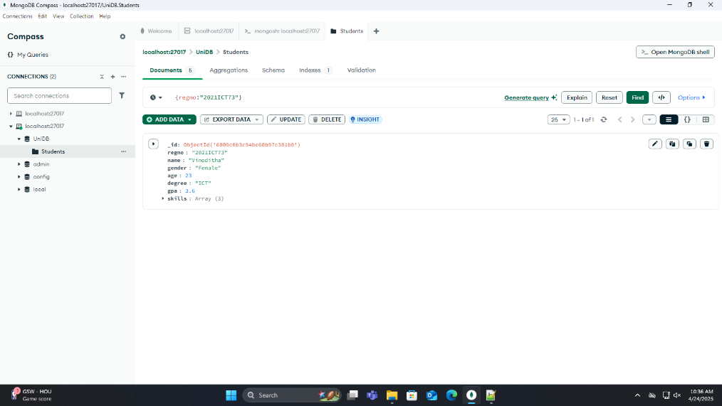Retrieving Data:

* Click Options
* Type inside the project

Changing the design of data Visibility:

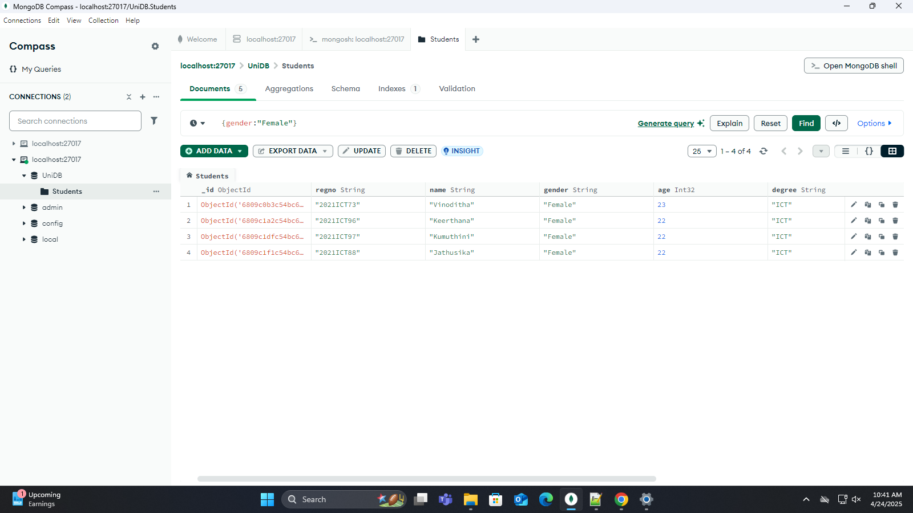

//Retrieving Using Shell:

* Using find key word

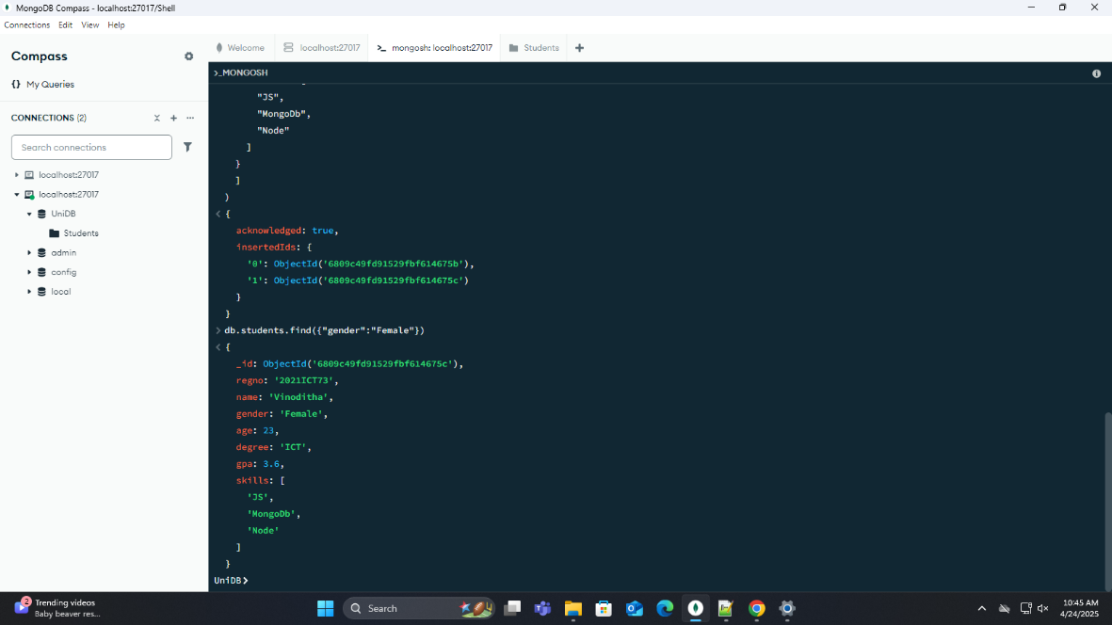

Using Greater than or less than keywords to retrieve data

* Using gt as keyword for greater than
* Using lt as keyword for less than

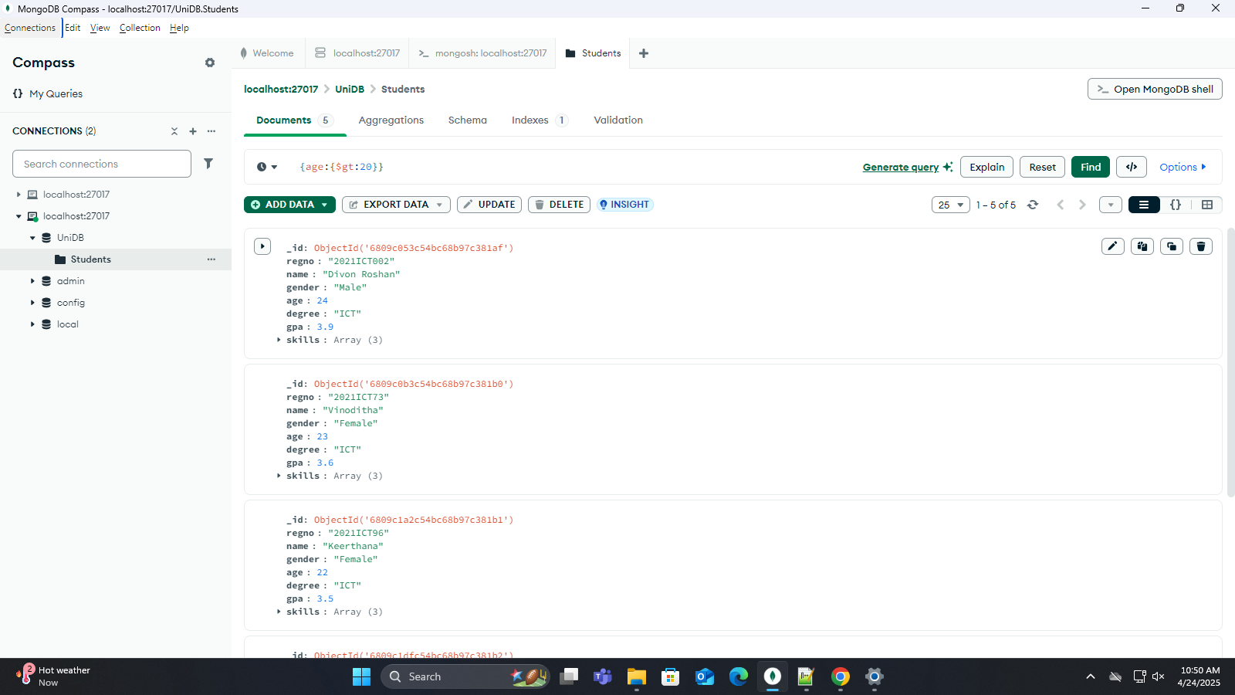

Using Same in Shell:

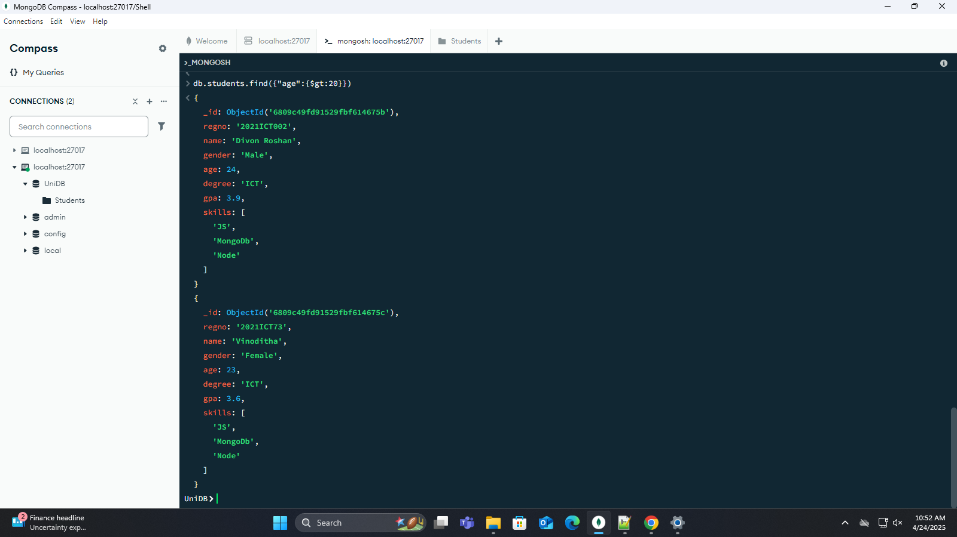

Sorting (Using GUI)

* Using GPA

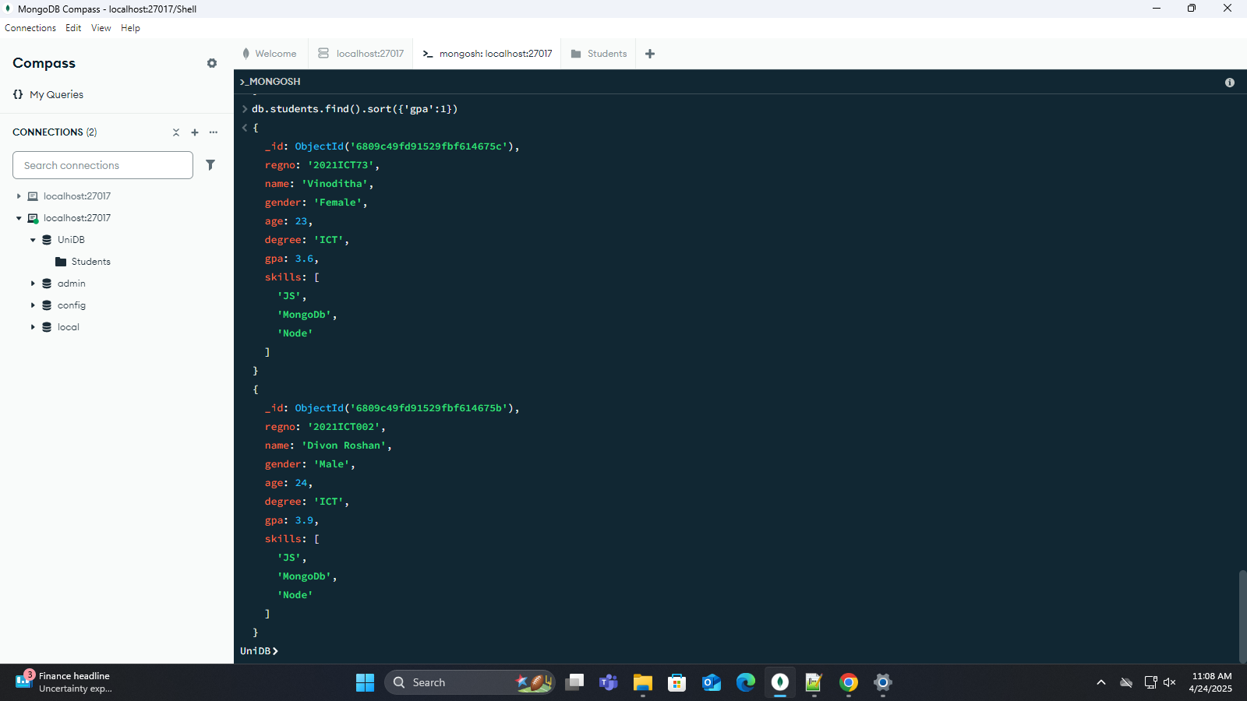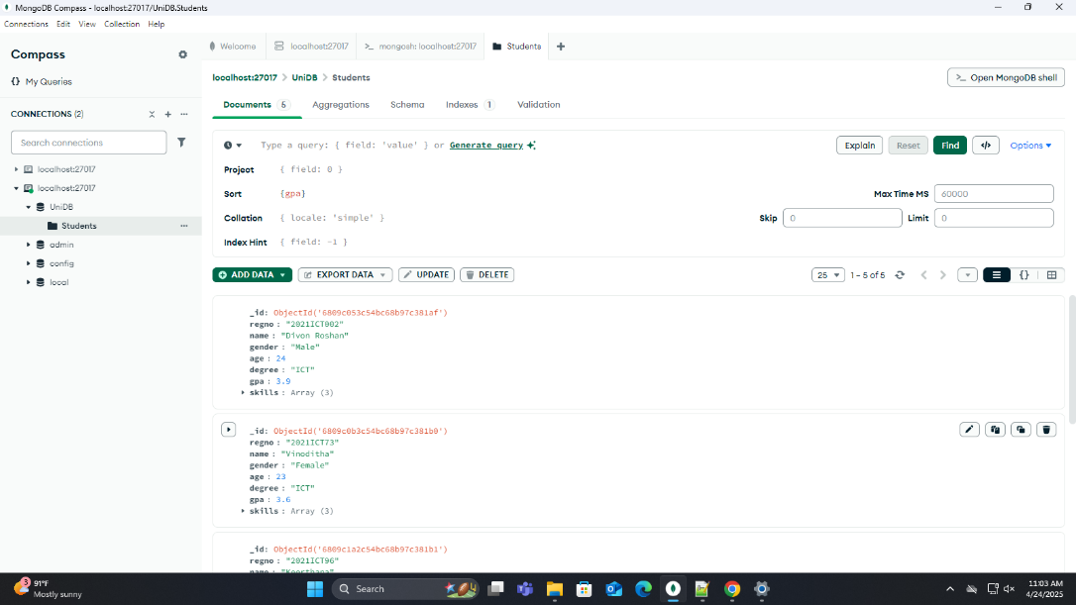Using Shell

Giving One or More Conditions Using Shell

